12A Exam 1 VERSION 1
Fall 2018 (Klein CH1, 2, tiny bit of 3)

1. What is the correct Lewis structure for nitric acid, HNO₃, including the formal charges?

2. Indicate the hybridization indicated atoms AND their partial charge (δ+/-)?
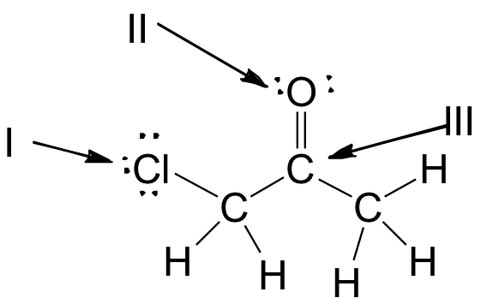

3. Which of the following compounds have both polar covalent and ionic bonds? Briefly explain your choice.

A. NH₄Br
B. H₂O₂
C. HCN
D. H₂S
E. None of these.

4. Which element has the following electronic configuration?

5. Clearly explain the difference between the formation of a sigma bond and a pi bond.

6. Explain clearly which compound(s) have trigonal planar molecular geometry?
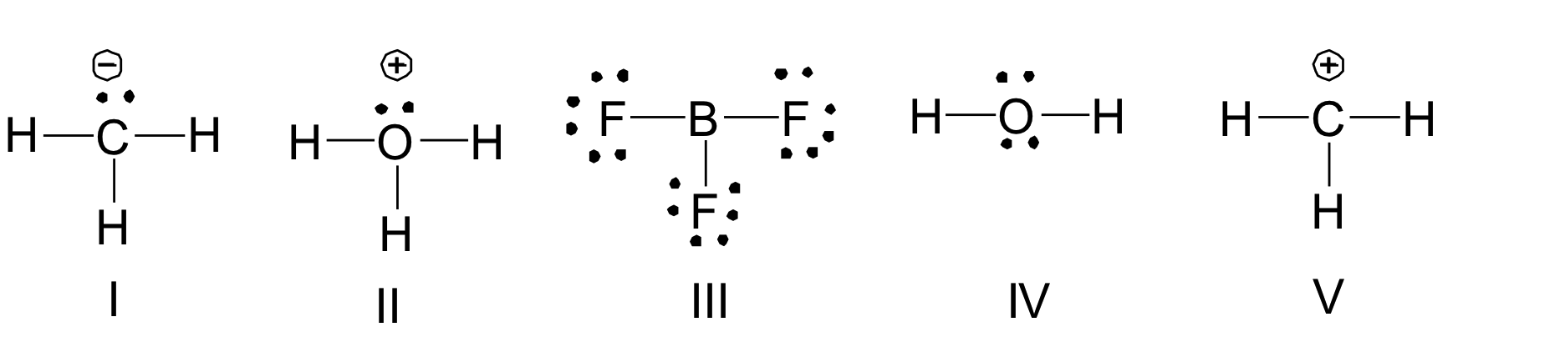

7. Tryptophan is an essential amino acid important in the synthesis of the neurotransmitter serotonin in the body. What are the hybridization state, molecular geometry and approximate bond angle at the indicated carbon and nitrogen atoms?
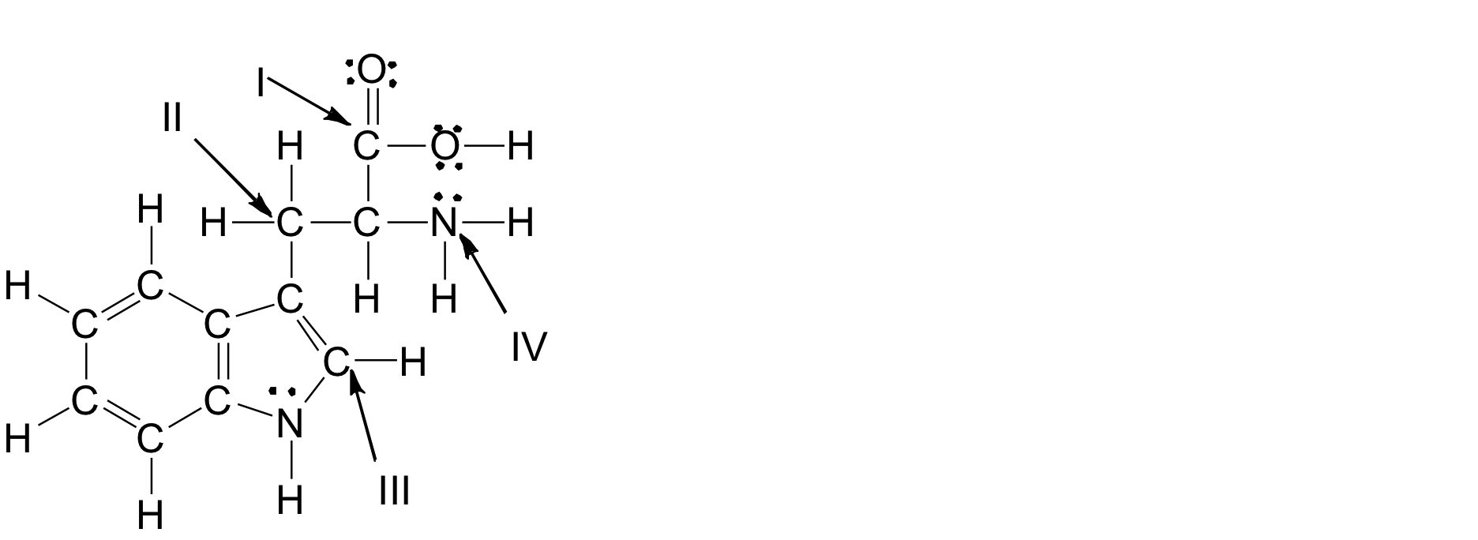

I II

III IV

8. Which of the following compounds are polar?

A. CBr₄
B. CO₂
C. CH₄
D. H₂O
E. C₂H₄

9. Rank the following compounds in decreasing order of boiling point AND list the strongest intermolecular force each molecule has.

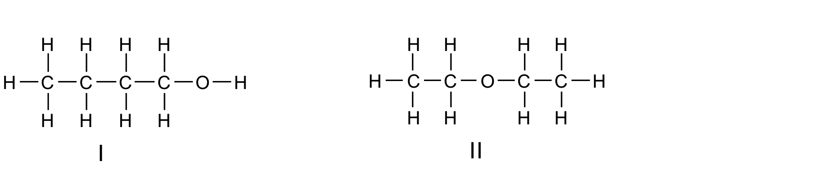

A. III > I > IV > II
B. II > IV > I > III
C. III > I > II > IV
D. IV > II > I > III
E. I > III > II > IV

10. Which of the following is the correct condensed structure for the following compound?

A. CH₂CH(CH₂)₃C(CH₃)₃
B. CH(CH₂)₄C(CH₃)₃
C. (CH₃)₂CH(CH₂) ₄CH₃
D. CH₂CH(CH₂)₃C(CH₃)₃
E. (CH)₃(CH₂)₃C(CH₃)₃

11. Which of the following is the correct bond-line structure for (CH₃)₂CHCH₂C(CH₃)₃?

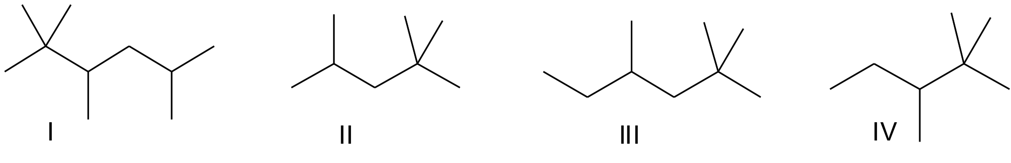

A. I
B. II
C. III
D. IV
E. None of these

12. Draw a proper (correct bond angles) Bond-Line Structure for a molecule that contains a carboxylic acid, an alkyne, and an ether.

13. What is the number one requirement when identifying resonance contributors that are most significant? (only one answer!)

14. What is the number one requirement that you look out to determine the strength of a base? Explain WHY? (be clear and to the point)

15. Which of the following is/are correct resonance structure(s) for compound A?

A. I and II
B. II and III
C. III and IV
D. I and III
E. I and IV

16. Draw a Bond-Line Structure for an Ester. Then use curved arrows to show the resonance to form another significant & stable resonance contributor.

17. Give the conjugate acid of the base NH₃. Indicate the strength of both molecules & briefly explain why.

Bonus (5%): Clearly and specifically explain the difference in base strength between an amine and an amide.

Name___________________________________

Good luck! Read carefully & budget your time appropriately! Please keep your eyes on your own exam at all times!

