Chem 12A ________________________________
Fall 2019

*Relax & good luck!

*Please make sure to do your own work. If your eyes feel the need to wander, please gaze at the ceiling or smile affectionately at me.

*Please read each question carefully. Have you following the directions? Are your explanations clear, detailed, and specific?

*A clear explanation is not simply…. “because it is big” or “that atom is electronegative…” An explanation should include why those things matter… does your answer show you understand the job of an acid or the job of a base?

*All bonds, lone pairs, formal charges, and arrows need to be shown where necessary. Proper shapes & angles are required.

*Remember to not hesitate too long on a question - move on and come back to those more challenging to you later.

*And of course, this is just a test – sure tests are important and you need to be putting the necessarily amount of time into the class, but your happiness in life is more important – relax… you’ll get there.

- Draw the conjugate acid of an amine in bond-line notation. Explain the strength of the acid using the acid’s structure.

- Draw the conjugate base of a carboxylic acid in bond-line notation. Explain the strength of the acid using the strength of the conjugate base’s structure.

- Circle the strongest base from the following.

–CH₃ –NH₂ –OCH₃ –OC(CH₃)₃

- Circle the strongest acid from the following.

(CH₃)₃COH CH₃CH₂OH

- Draw a bond-line structure that has two sp carbon atoms and one sp³ carbon atom.

- Show the complete mechanism for the reaction between NaOCH₃ and sulfuric acid. Does the reaction favor the products or the reactants? Explain.

- Explain what type of hybridization a stable base would have. Give an example of such a base.

- Label the hybridization of the indicated atoms as well as their molecular geometry and approximate bond angles.

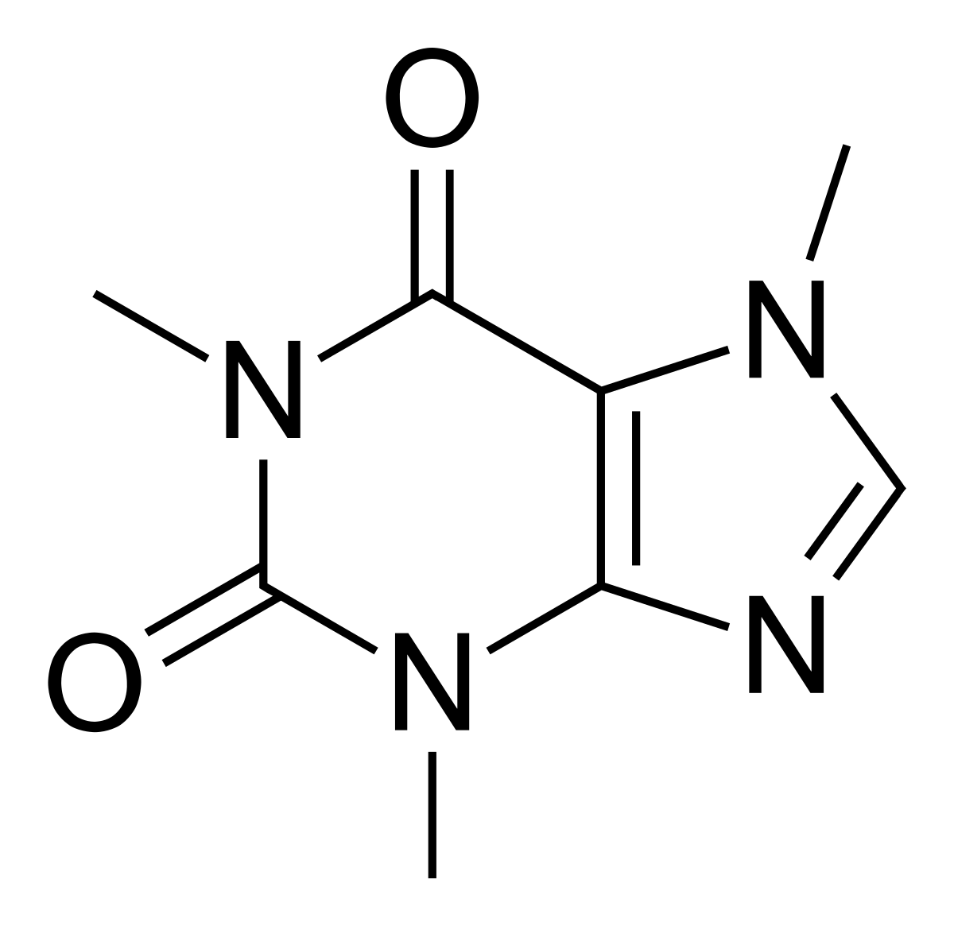

9.
a. Show the resonance of an ester that results in a stable resonance contributor. Use bond-line notation. (Be sure to include appropriate arrows to show flow of electrons).

b. Show the resonance of an amide that results in a less stable resonance contributor. Use bond-line notation. (Be sure to include appropriate arrows to show flow of electrons).

10.
a. Show the complete mechanism for the reaction between an amine and hydrochloric acid.

b. Would water have been an appropriate acid to use in 10a.? Explain.

11. Draw the bond-line structure for:

- (CH₃)₂CHC(CH₃)₂CH₂CH₃

b. CH₃CH(COOCH₃)₂

12. Use ONE WORD to indicate what is mainly affecting the strength of the following bases:

- –OCH₂F ___________________

- –OCOCH₃ ___________________

Bonus (5%)

Write the name of a functional group that exhibits the following:

…. Has dipole-dipole interactions as strongest force = ______________________

…. Has H-bonding and no sp² carbons = _____________________

