Organic Chemistry 12BL Spring 2020

Mon/Wed Schedule

*Please note: lecture and lab are two separate courses – schedules will not necessarily correspond identically.

Week of…. Monday Wednesday

1/6 Check-in In-class Packet

1/13 1) Diels Alder 1) Diels Alder

1/20 No School 2) Extraction &
Saponification

1/27 2) Extraction & 3) Salicylic Acid
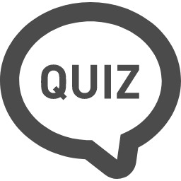
Saponification Synthesis
Quiz (Expts 1 & 2)

2/3 3) Salicylic Acid 4) Aspirin Synthesis
Synthesis

2/10 4) Aspirin Synthesis 5) Vanillin Reduction
Quiz (Expts 3 & 4)

2/17 No School 5) Vanillin Reduction

2/24 6) NMR Analysis 6) NMR Analysis

3/2 7) Directive Effects in 7) Directive Effects in
the Bromination of the Bromination of
Vanillin Vanillin
Quiz (Expts 5 & 6)
Week of… Monday Wednesday

3/9 8) Friedel Crafts 8) Friedel Crafts
Acylation Acylation

3/16 9) Aldol-Condensation 9) Aldol Condensation-
Dehydration Dehydration
Quiz (Expts 7 & 8)

3/23 9) Aldol-Condensation- 10) Diazo Dyes Dehydration

3/30 10) Diazo Dyes 10) Diazo Dyes
(Mandatory tie-dye)

4/6 Spring Break Spring Break

4/13 11) Multi-Step 11) Multi-Step
Synthesis Synthesis
Quiz (Expts 9 & 10)

4/20 11) Multi-Step 11) Multi-Step
Synthesis Synthesis

4/27 11) Multi-Step 11) Multi-Step
Synthesis Synthesis
Quiz (Expt 11)

5/4 Lab Practical Lab Practical

Important Dates to Remember:
Last day to drop without a W 1/24
Last day to drop with a W 4/17

